PROJECT REPORT

On

# Tripx-Tour and Travel WebApp

Submitted in partial fulfilment of the requirement for the Course BEE (22CS026) of

COMPUTER SCIENCE AND ENGINEERING

B.E. Batch-2022

## in

Sep-2024



|  |  |  |  |  |  |  |
| --- | --- | --- | --- | --- | --- | --- |
| Under the Guidance of | | | | Submitted By | | |
| Ms Preenu Mittan | | | Ansh | | | |
|  | | | | 2210991289 | | |
|  | | | | Ansh Arora | | |
|  | | | | 2210991290 | | |
|  | | |  | | | |
|  | | |  | | | |
|  | | |  | | | |
|  | | |  | | | |
|  | | |  | | | |

DEPARTMENT OF COMPUTER SCIENCE AND ENGINEERING

# CHITKARA UNIVERSITY

PUNJAB

## (Annexure –C)

CERTIFICATE

This is to be certified that the project entitled Tripx-Tour and Travel WebApp has been submitted for the Bachelor of Computer Science Engineering at Chitkara University, Punjab during the academic semester July 2024- December-2024 is a bonafide piece of project work carried out by Ansh 2210991289, Ansh Arora 2210991290 towards the partial fulfilment for the award of the course Integrated Project (CS 203) under the guidance of

Ms Preenu Mittan and supervision.

Sign. of Project Guide:

Ms Preenu Mittan

(Designation & Department)

## (Annexure –D)

CANDIDATE’S DECLARATION

We, Ansh 2210991289, Ansh Arora 2210991290 of G-17, B.E.-2022 of the Chitkara University, Punjab hereby declare that the Integrated Project Report entitled “Tripx-Tour and Travel WebApp” is an original work and data provided in the study is authentic to the best of our knowledge. This report has not been submitted to any other Institute for the award of any other course.

|  |  |  |
| --- | --- | --- |
| Sign. of Student 1 | Sign. of Student 2 |  |
| Ansh | Ansh Arora |  |
| 2210991289 | 2210991290 |  |

Place: CUIET Date: 3-9-24

## (Annexure -E)

ACKNOWLEDGEMENT

It is our pleasure to be indebted to various people, who directly or indirectly contributed in the development of this work and who influenced our thinking, behaviour and acts during the course of study.

We express our sincere gratitude to all for providing me an opportunity to undergo Integrated Project as the part of the curriculum.

We are thankful to Ms Preenu Mittan for her support, cooperation, and motivation provided to us during the training for constant inspiration, presence and blessings.

Lastly, we would like to thank the almighty and our parents for their moral support and friends with whom we shared our day-to day experience and received lots of suggestions that improve our quality of work.

|  |  |
| --- | --- |
| Ansh | Ansh Arora |
| 2210991289 | 2210991290 |

## (Annexure –F)

**Table of Contents**

|  |  |  |
| --- | --- | --- |
| Sr No. | Title | Page No. |
| 1. | Abstract/Keywords | 6 |
| 2. | Introduction to the project | 7-9 |
| 3. | Software and Hardware Requirement Specification | 10-13 |
| 4. | Program’s Structure Analyzing and GUI Constructing | 14-17 |
| 5. | Code-Implementation and Database Connections | 18 |
| 6. | Limitations | 19 |
| 7. | Conclusion | 20 |
| 8. | Future Scope | 21 |
| 9. | Bibliography | 22 |

**1.Abstract**

Tripx is a modern and dynamic travel website designed to enhance the user experience in planning and booking trips. The platform offers users a seamless interface to explore various destinations, view detailed package information, and make bookings. The key features of Tripx include a detailed package description, user reviews, and a secure booking process. The project was developed using React for the frontend, Tailwind CSS for styling, and Node.js for backend operations. The database structure ensures efficient storage and retrieval of package details, user data, and booking information.

Tripx addresses the challenges of traditional travel planning by providing a user-friendly platform that consolidates all necessary travel information in one place. Users can browse through multiple destinations, check the availability of packages, and read reviews before making a booking decision. The platform also includes features like a toast notification system to enhance user interaction and ensure a smooth booking process.

The project aims to simplify the travel planning process, offering users an easy-to-navigate interface with all essential travel information readily available. With an emphasis on responsive design, Tripx ensures that users can access the platform across various devices, providing a consistent and enjoyable user experience.

**Keywords:** Travel website, React, Tailwind CSS, Node.js, destination packages, user reviews, booking system, responsive design, user interface, Tripx.

**2. Introduction**

Tripx is a comprehensive travel platform designed to revolutionize how travellers explore, plan, and book their journeys. The project was conceived with the vision of creating a seamless and intuitive experience for users, enabling them to discover new destinations, compare travel packages, and make informed decisions about their trips—all in one place. Tripx is tailored to meet the needs of modern travellers who demand efficiency, convenience, and reliability when planning their travels.

In today's fast-paced world, the traditional methods of planning a trip—searching multiple websites, reading numerous reviews, and comparing various packages—can be overwhelming and time-consuming. Tripx addresses this issue by integrating all these functionalities into a single, user-friendly platform. The platform not only allows users to browse through a wide array of travel destinations but also provides detailed information about each location, including package prices, duration, user reviews, and booking options.

The development of Tripx was driven by the need to simplify the travel planning process and enhance the overall user experience. The platform leverages the power of modern web technologies, including React for building a dynamic and responsive user interface, and Tailwind CSS for creating visually appealing and mobile-friendly designs. The backend is powered by Node.js, ensuring robust and efficient data handling and server management.

Tripx stands out by offering a unique combination of features that cater to both casual travellers and seasoned explorers. Whether users are looking for a quick weekend getaway or a detailed itinerary for a long vacation, Tripx provides all the necessary tools and information to make the planning process effortless. The platform's search functionality allows users to find the best destinations based on their preferences, while the package details and reviews give them the confidence to make informed decisions.

The goal of Tripx is to become the go-to platform for all travel planning needs, offering users a smooth, hassle-free experience that saves them time and effort. By integrating advanced search capabilities, detailed package descriptions, and secure booking options, Tripx aims to transform how people plan their travels, making it easier, faster, and more enjoyable.

**2.1 Background**

The idea for Tripx emerged from the challenges faced by travellers in the digital age. Traditionally, planning a trip involved visiting multiple websites to gather information about destinations, compare prices, and read reviews. This fragmented approach often led to confusion, frustration, and an overwhelming amount of information, making it difficult for travellers to make confident decisions. The need for a more streamlined and efficient solution became increasingly apparent.

The travel industry has seen significant advancements in recent years, with more people relying on online platforms to plan and book their trips. However, despite the availability of numerous travel websites and apps, there remained a gap in the market for a platform that could provide a truly comprehensive and user-centric experience. Most existing platforms either focused solely on booking or offered limited information, forcing users to navigate multiple sites to gather all the details they needed.

Recognizing these challenges, Tripx set out to create a platform that would address the pain points of modern travellers. The goal was to build a solution that would consolidate all aspects of travel planning into one cohesive platform, making it easier for users to explore destinations, compare packages, read reviews, and book their trips with confidence. The team conducted extensive research to understand the needs and preferences of travellers, which informed the design and functionality of Tripx.

The platform was designed to be intuitive and user-friendly, with a focus on providing a seamless experience across all devices. The use of React and Tailwind CSS allowed the development team to create a responsive and visually appealing interface, while Node.js ensured that the backend was capable of handling large amounts of data and traffic efficiently. The result is a platform that not only meets the needs of today's travellers but also anticipates future trends in the travel industry.

**2.2 Problem Statement**

The primary problem that Tripx seeks to address is the inefficiency and inconvenience associated with traditional travel planning methods. In the current landscape, travellers often have to visit multiple websites to gather the information they need to plan a trip. This disjointed process can be time-consuming and frustrating, leading to a less enjoyable travel planning experience.

One of the major pain points for travellers is the lack of a unified platform that offers comprehensive travel information in one place. While there are many websites and apps available, they often focus on specific aspects of travel, such as booking flights or hotels, without providing a holistic view of the entire travel experience. As a result, users are forced to jump between different platforms, leading to information overload and difficulty in making informed decisions.

Another significant challenge is the lack of reliable reviews and detailed package information. Many travellers rely on reviews from other users to make decisions about where to go and what packages to choose. However, the absence of a standardized review system and inconsistent package details across different platforms can make it difficult for users to trust the information they find.

Tripx aims to solve these problems by offering a centralized platform where travellers can find all the information they need to plan their trips. The platform provides detailed descriptions of travel packages, including prices, duration, and user reviews, allowing users to make informed decisions with confidence. The integration of a robust search functionality further enhances the user experience by making it easy to find the best destinations and packages based on individual preferences.

By addressing these challenges, Tripx not only simplifies the travel planning process but also enhances the overall experience for users. The platform is designed to be intuitive, efficient, and reliable, providing travellers with the tools they need to plan their trips quickly and easily. In doing so, Tripx aims to become the go-to platform for all travel planning needs, transforming how people approach travel in the digital age.

**3. Software and Hardware Requirement Specification**

For a project like Tripx, where the goal is to create a robust, user-friendly travel platform, both software and hardware requirements play a crucial role in ensuring optimal performance, scalability, and user satisfaction. The selection of the right tools, technologies, and hardware resources is critical to achieving the desired functionality and responsiveness of the application.

**Software Requirements:**

1. **Operating System:**
   * **Development Environment:** The project is developed in a cross-platform environment, supporting Windows, macOS, and Linux. This ensures that developers can work on any preferred operating system.
2. **Development Tools:**
   * **Code Editor/IDE:** Visual Studio Code is the primary Integrated Development Environment (IDE) used for developing the Tripx platform. It is lightweight, supports numerous extensions, and is highly customizable to fit the needs of different developers.
   * **Version Control:** Git is used for version control, allowing multiple developers to collaborate efficiently. GitHub hosts the project’s repository, providing a platform for code management, issue tracking, and continuous integration/continuous deployment pipelines.
3. **Programming Languages:**
   * **Frontend:** The frontend is developed using JavaScript, with React as the primary framework. React is chosen for its ability to build dynamic and responsive user interfaces, essential for a smooth user experience.
   * **Backend:** The backend is developed using Node.js, which provides a non-blocking, event-driven architecture. This is ideal for handling the high concurrency required in a web application like Tripx.
   * **Database:** MongoDB is the database used, offering flexibility and scalability, which are vital for handling the diverse and growing data needs of a travel platform.
4. **Libraries and Frameworks:**
   * **React:** The primary frontend framework, chosen for its component-based architecture, allowing for reusable code and efficient management of complex user interfaces.
   * **Tailwind CSS:** A utility-first CSS framework used to design the frontend, enabling rapid development of custom user interfaces without leaving the HTML.
   * **Express.js:** A Node.js web application framework used to build the backend, providing a robust set of features for web and mobile applications.
   * **Mongoose:** An Object Data Modelling (ODM) library for MongoDB, used to manage data relationships, schema validation, and business logic.

**Hardware Requirements:**

1. **Development Machines:**
   * **Processor:** A modern multi-core processor (e.g., Intel Core i5/i7 or AMD Ryzen 5/7) is recommended to handle the demands of running multiple development tools, local servers, and virtual machines.
   * **RAM:** A minimum of 8GB of RAM is required, with 16GB or more recommended for a smoother development experience, especially when running multiple services simultaneously.
   * **Storage:** SSD storage is preferred, with at least 256GB capacity to store the operating system, development tools, and project files efficiently.
   * **Display:** A high-resolution monitor (1080p or higher) is recommended for better visibility when coding and designing the user interface.
2. **Server Specifications:**
   * **Processor:** The deployment server should have at least a quad-core processor to handle multiple requests simultaneously.
   * **RAM:** A minimum of 8GB of RAM is recommended, with the ability to scale up as the user base grows.
   * **Storage:** The server should have SSD storage for faster read/write speeds, with a minimum capacity of 256GB to accommodate the database, application files, and logs.
   * **Network:** A high-speed internet connection with low latency is essential for a seamless user experience, especially when the application involves real-time data retrieval and updates.

**3.1 Methods**

The development methodology for Tripx revolves around agile practices, ensuring that the project is built incrementally with regular feedback loops, which helps in adapting to changes quickly and efficiently. Agile methodology allows the development team to work in iterative cycles, known as sprints, where each sprint focuses on a specific set of features or improvements. This approach ensures that the project remains on track, and any issues can be identified and resolved early in the development process.

**3.2 Programming/Working Environment**

The programming environment for Tripx is designed to be conducive to collaboration, productivity, and efficiency. The tools and technologies chosen are not only industry-standard but are also selected for their ability to integrate seamlessly with each other, providing a smooth and cohesive development experience.

**Development Tools:**

1. **Visual Studio Code (VS Code):**
   * VS Code is the primary code editor used by the development team. It is favoured for its lightweight design, speed, and extensive library of extensions, which enhance functionality and streamline the development process. Key extensions used include Prettier for code formatting, ESLint for maintaining coding standards, and GitLens for better version control management.
2. **Node.js and npm:**
   * Node.js is used as the runtime environment for the backend development. It allows the use of JavaScript on the server side, enabling full-stack development within a single language. npm (Node Package Manager) is used to manage project dependencies, ensuring that all necessary libraries and packages are up-to-date and properly installed.
3. **Git and GitHub:**
   * Git is the version control system used for managing code changes, and GitHub is the platform where the code repository is hosted. The team uses Git for branching, merging, and managing different versions of the project. GitHub Actions is used for setting up CI/CD pipelines, ensuring that every code change is automatically tested and deployed.
4. **Postman:**
   * Postman is used for API testing and development. It allows the team to create, test, and document API requests, ensuring that the backend services are working correctly and are well-documented for frontend integration.

**3.3 Requirements to Run the Application**

For Tripx to run smoothly in a production environment, several software and hardware requirements need to be met. These requirements ensure that the application is accessible to users, performs efficiently, and is secure.

**Software Requirements:**

1. **Web Server:**
   * **Nginx/Apache:** A web server like Nginx or Apache is required to serve the static files of the frontend and to act as a reverse proxy for the backend API. Nginx is preferred for its performance and scalability, especially when handling high traffic loads.
2. **Database Server:**
   * **MongoDB:** MongoDB is the primary database for Tripx, requiring a server capable of handling read and write operations efficiently. MongoDB Atlas is a cloud-based solution that offers automatic scaling, backups, and monitoring, making it an ideal choice for production environments.
3. **Operating System:**
   * **Windows:** The production server should run on a Windows distribution which is known for its stability and security. Regular updates and patches should be applied to ensure the server remains secure.

**4.Program’s Structure Analyzing and GUI Constructing**

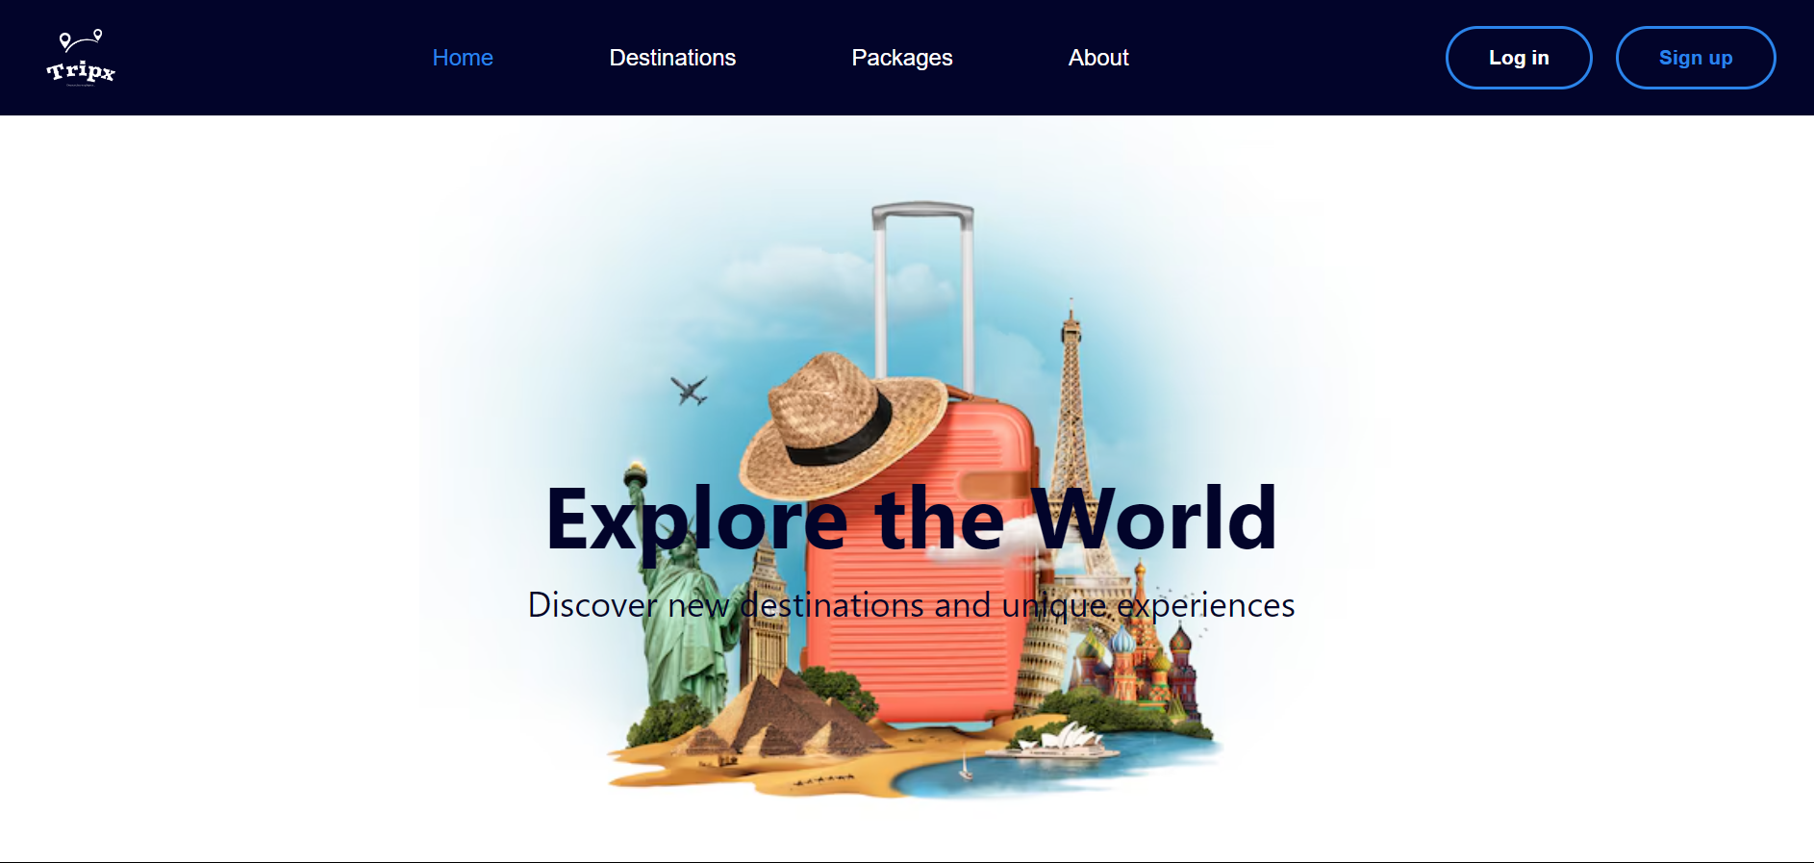

­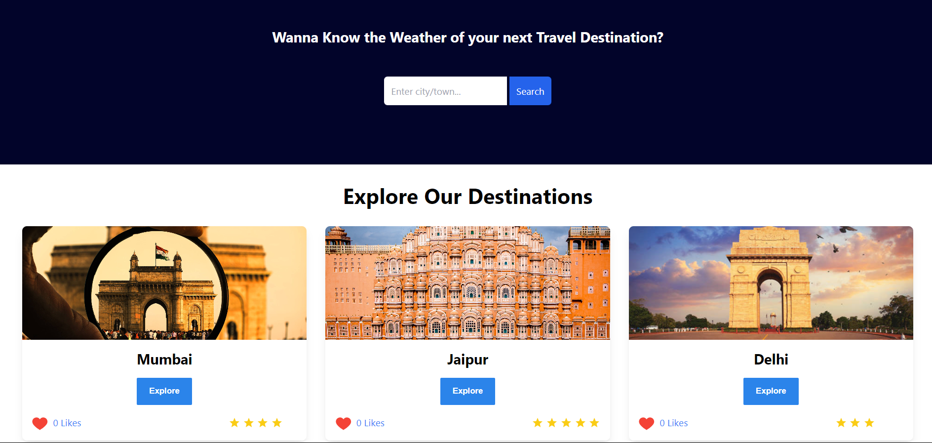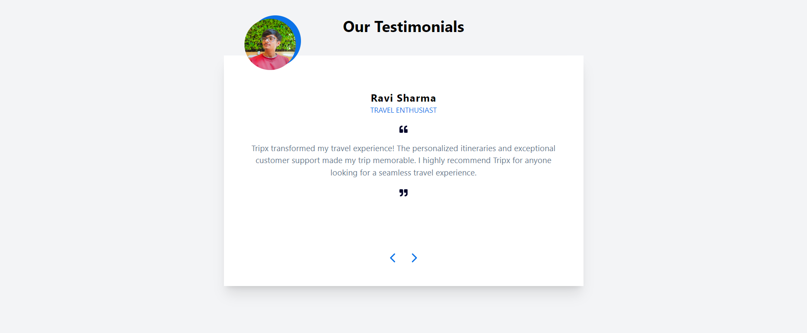



**Home Page**

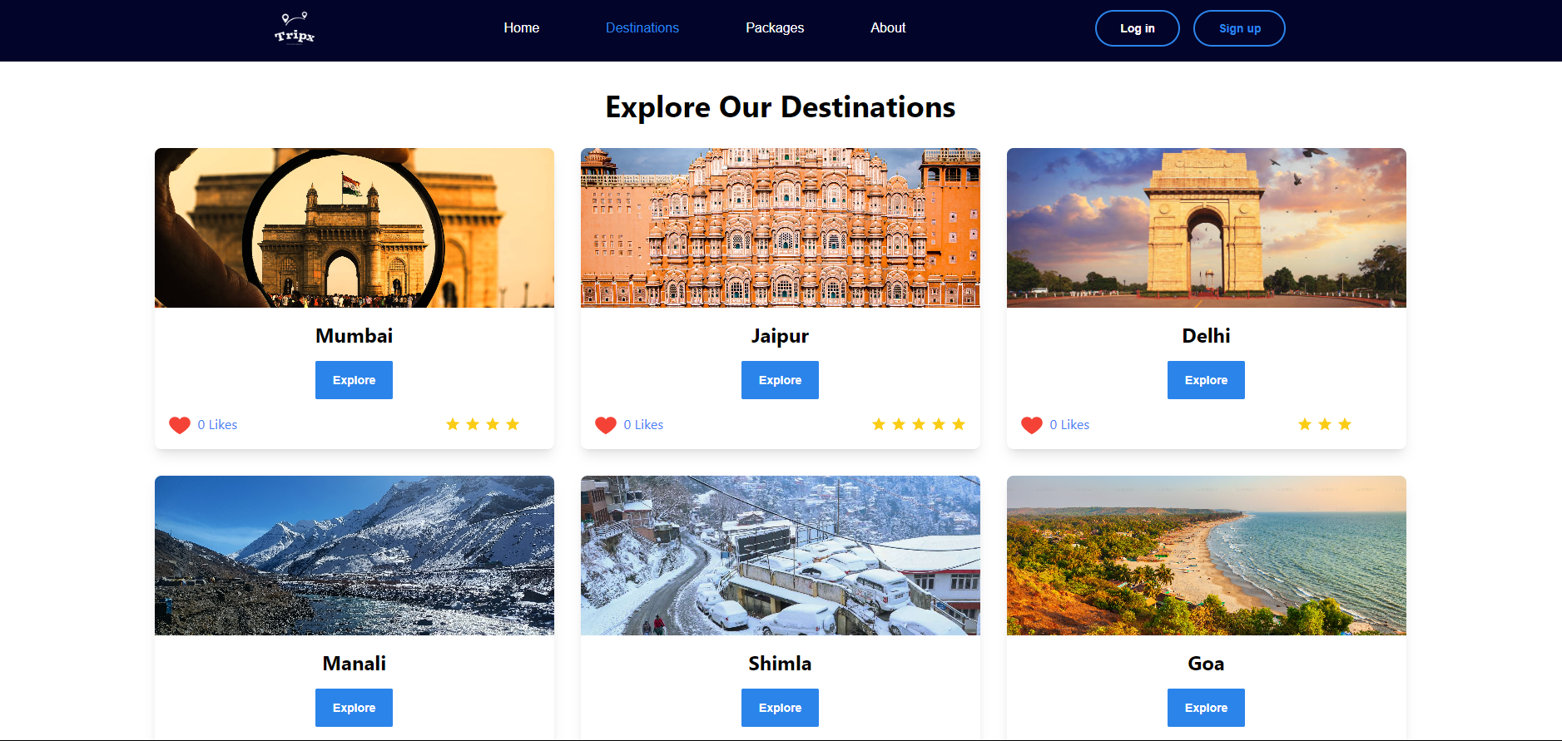

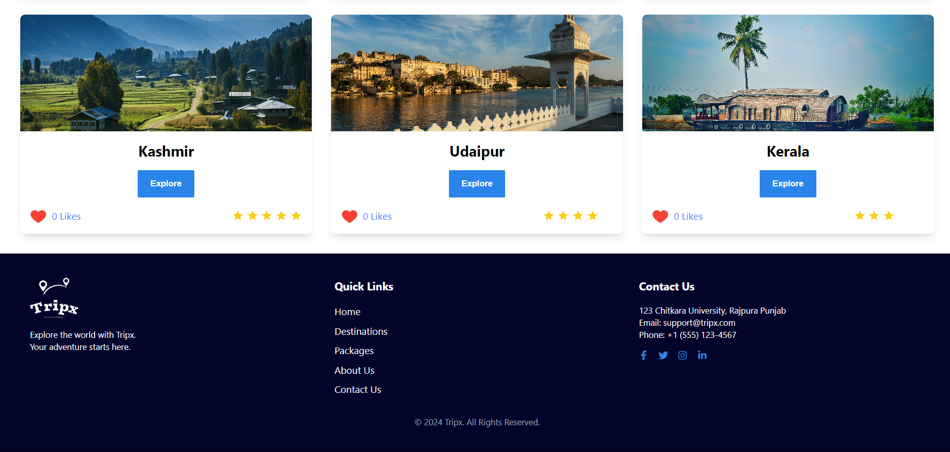

**Our Destinations**



**SignUp Page**

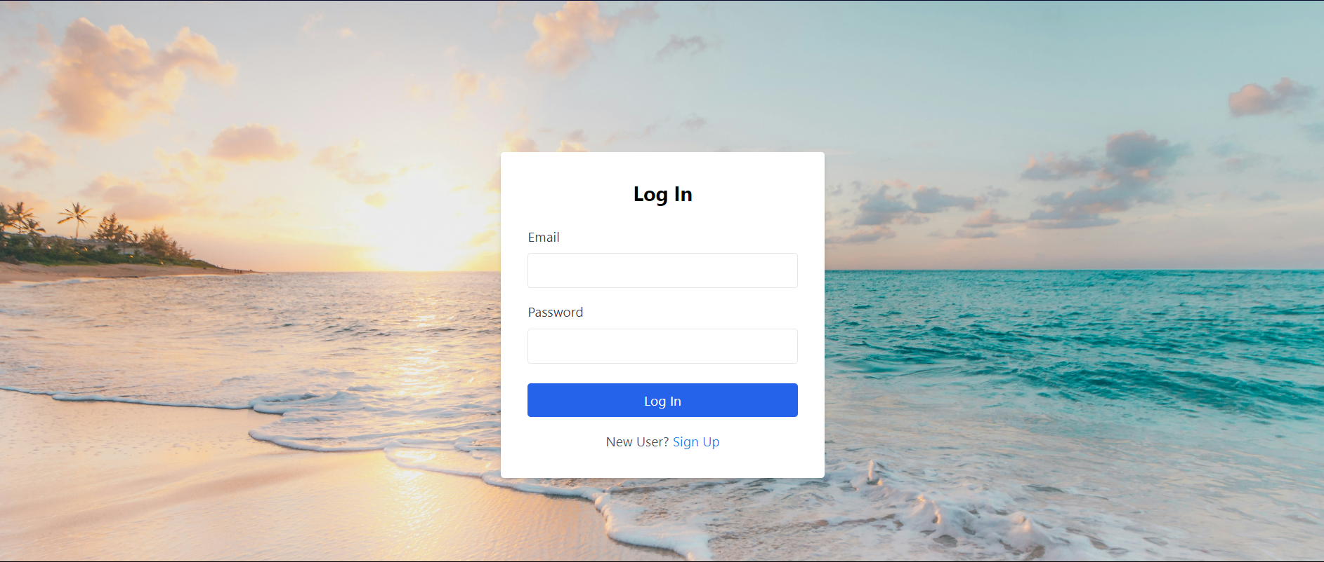

**Login Page**

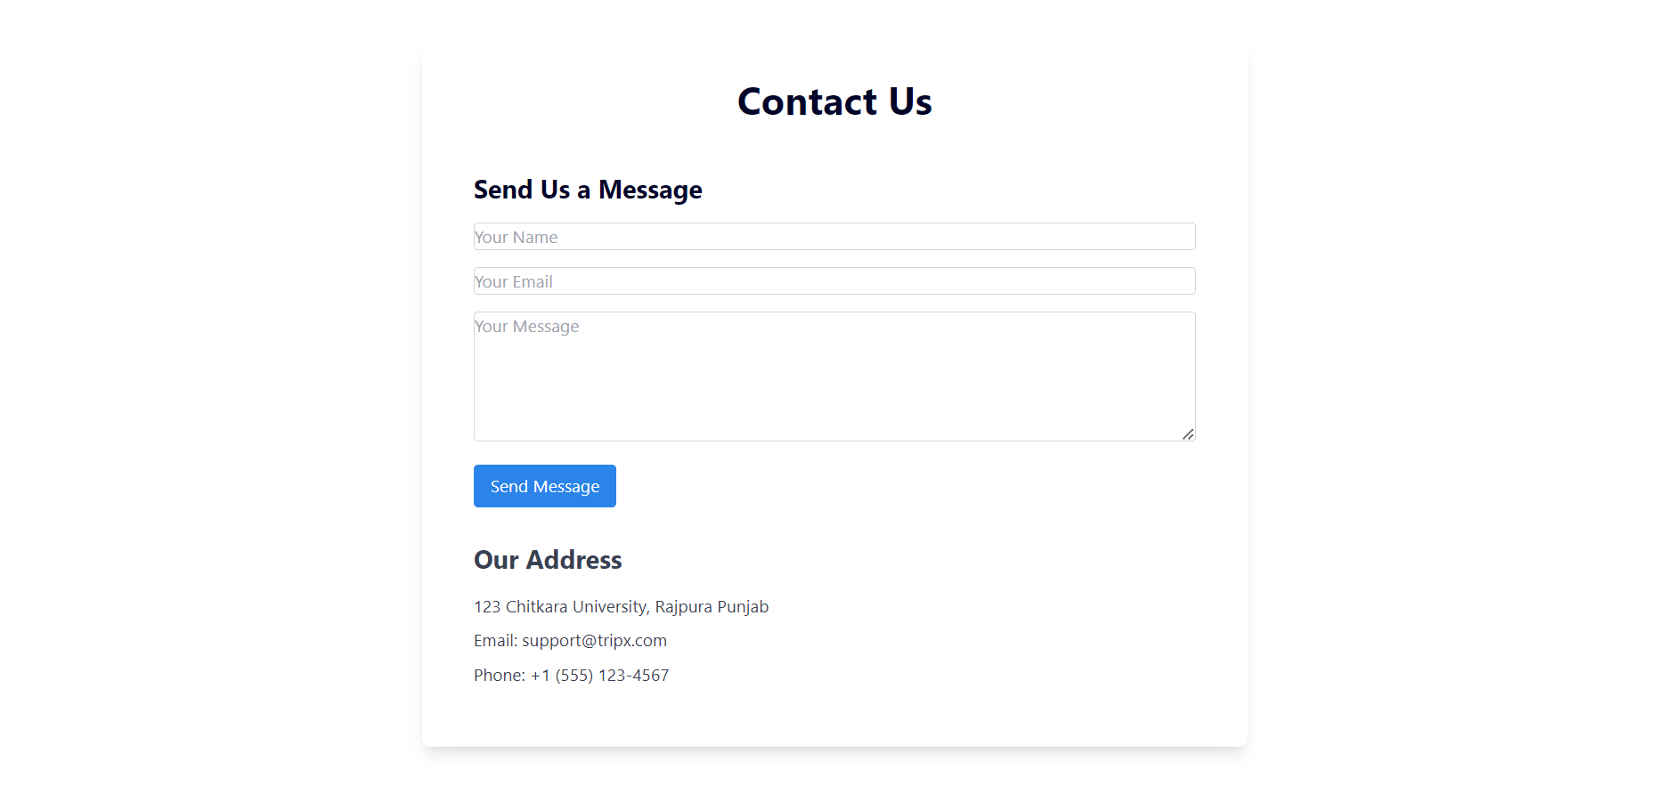

Contact-us



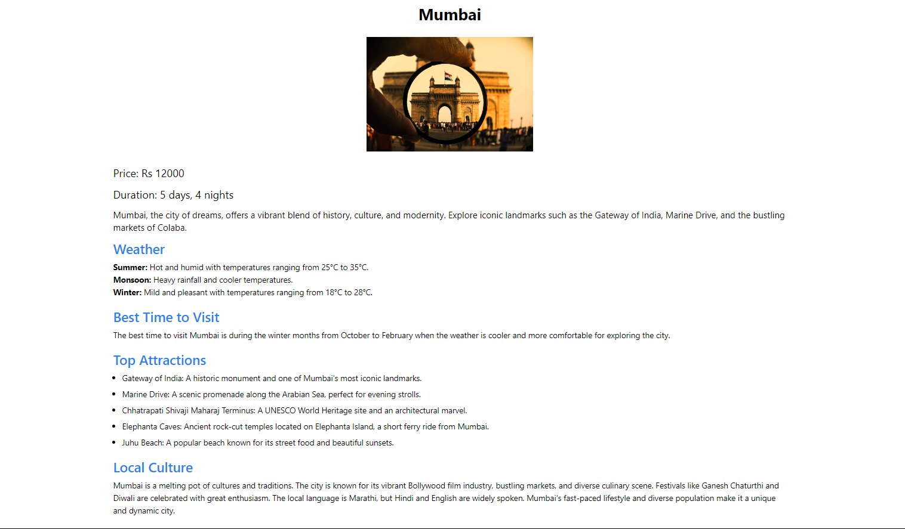

**Explore and Booking Page**

**5. Code-Implementation and Database Connections**

The code implementation of Tripx involves creating a dynamic and responsive web application using React for the frontend and Node.js with Express for the backend. The frontend is structured with reusable components, including a header, destination cards, and detailed package pages. React Router is utilized for seamless navigation, while state management is handled using React’s useState and useEffect hooks. Tailwind CSS is employed for styling, ensuring a modern and responsive design.

The backend is built with Node.js and Express, which manages API endpoints for various operations like fetching destinations, handling user authentication, and processing bookings. JWT (JSON Web Token) is used for secure user authentication, with tokens stored in local storage on the frontend.

For the database, MongoDB is chosen for its flexibility and scalability, with Mongoose as the ORM (Object-Relational Mapping) tool to define schemas and manage data. The database operations, such as creating, reading, updating, and deleting records, are efficiently handled by Mongoose. Connection to the MongoDB database is managed through Mongoose, ensuring a stable and secure connection. Data validation and security measures are implemented to protect against injection attacks and ensure data integrity.

**6. Limitations**

While Tripx offers a robust platform for booking travel packages, several limitations exist that could impact user experience and system performance:

1. Limited Real-time Data: The current implementation does not support real-time data updates. For example, package availability, pricing, and reviews are static, meaning any changes in these aspects on the service provider’s end are not reflected immediately in the application. This could lead to discrepancies between the information presented to users and the actual status of the travel packages.
2. Scalability Issues: As the platform grows and the number of users and travel packages increases, the current infrastructure might face scalability challenges. The application is currently hosted on a basic server setup, which may not efficiently handle high traffic volumes or a large number of concurrent users, leading to slower load times or potential downtimes.
3. No Multi-Language Support: The application is only available in English, which limits accessibility for non-English speaking users. Adding multi-language support would require significant changes to the codebase and content management.

**7.Conclusion**

The Tripx successfully provides a comprehensive travel solution that enables users to explore, book, and manage their travel packages efficiently. By integrating a user-friendly interface with key features such as destination browsing, package booking, and real-time updates, Tripx addresses the core needs of travelers seeking a seamless and engaging experience.

The project's implementation showcases effective use of modern technologies and design principles, ensuring both functionality and aesthetic appeal. While the current version meets the essential requirements and provides a solid foundation, there is potential for future enhancements to further improve user experience and expand functionality.

In summary, Tripx not only meets its initial objectives but also sets the stage for ongoing development and improvement, promising to evolve into a robust platform that adapts to the changing needs of its users.

**8. Future Scope**

* Flight and Car Rental Bookings: Extend the app’s capabilities to include flight reservations and car rentals, providing a more comprehensive travel solution.
* Local Experiences and Tours: Partner with local service providers to offer users the ability to book unique experiences, guided tours, and activities at their destination.
* User Reviews and Ratings: Allow users to leave reviews and ratings for accommodations, attractions, and services, helping others make informed decisions.
* Social Sharing and Trip Journals: Enable users to create and share trip journals or travel blogs directly within the app, fostering a community of travelers.
* Carbon Footprint Calculator: Include features that allow users to calculate the carbon footprint of their travel plans and suggest eco-friendly alternatives.
* Eco-Friendly Travel Options: Partner with eco-friendly accommodations and services to promote sustainable travel options to users.

**9.Bibliography**

**References:**

* React documentation: https://reactjs.org/docs/getting-started.html
* Tailwind CSS documentation: <https://tailwindcss.com/docs>
* React Router documentation: https://reactrouter.com/en/main
* React Toastify documentation: https://fkhadra.github.io/react-toastify/introduction